Occupied ball

The abbreviation “O” is usually used to confirm that the batter-runner’s advance to first base occurred as a result of the fielder’s choice to put out a preceding runner. An essential prerequisite is that, during the action, the chosen runner is put out or saved only by an error.
In fact, “occupied ball” always follows a fielding chance, whether the outcome is a putout or an error.
The “O” for “occupied ball” is followed by the number of the fielder who, once the hit ball has been recovered, initiates the alternative play.
Example 52: The “O6” noted in the first base square clearly indicates that if the shortstop had played for the batter-runner,he would certainly have been put out.
WBSC |  | Traduction dans l’outil de scorage |  | Outil
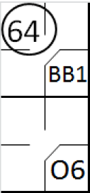 |  | /* le premier batteur gagne la première base un 'base on ball' */  action { batter -> BB }  /* Le batteur suivant frappe une balle vers l'arrêt court qui récupère la balle et la relaie ay défenseur de deuxième base pour retirer le coureur */  action { batter -> O6 , runner1 -> 64 } |  | 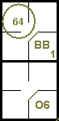

Example 53: The forced runner reaches base safely thanks to a catching error by the second baseman receiving a throw from the shortstop. In both cases the occupied ball notation is used after a fielding chance.
WBSC |  | Traduction dans l’outil de scorage |  | Outil
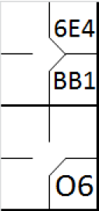 |  | /* le premier batteur gagne la première base un 'base on ball' */  action { batter -> BB }  /* Le batteur suivant frappe une balle vers l'arrêt court qui récupère la balle et la relaie au défenseur de deuxième base pour retirer le . Le défenseur commet une erreur en relâchant la balle */  action { batter -> O6 , runner1 -> 6E4 } |  | 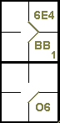

Example 54: With less than two out and runners on first and third, the third batter hits a fly ball to the center fielder, who muffs an easy catch.
While the lead runner scores, the outfielder recovers the ball and assists the shortstop in putting out the next runner, who is forced to advance by the error.
Since OBR 9.12(d)(4) states that no error is charged when a runner is subsequently forced out, the batter-runner’s advance to first base is recorded as an occupied ball.
The sacrifice fly in the example indicates that the run would have been scored even without the outfielder’s error.
WBSC |  | Traduction dans l’outil de scorage |  | Outil
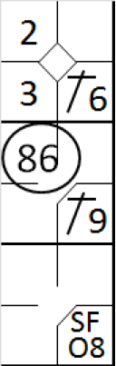 |  | /* le premier batteur frappe un hit sur l'arrêt court */  action { batter -> 1B6 }  /* Le batteur suivant frappe un simple dans le champ droit, le coureur avance de deux bases */  action { batter -> 1B9 , runner1 -> ++ }  /* Le frappeur suivant frappe une fly dans le champ centre qui loupe la balle. Le défenseur récupère la balle et la renvoie à l'arrêt pour retirer e coureur arrivant en 2. Le coureur en 3 marque le point */  action { batter -> SFO8 , runner1 -> 86 , runner3 -> + } |  | 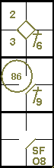

This is not the case for the example 55, where the absence of any notation of the sacrifice fly and the error for the arrival on home base demonstrates clearly that without the error no run would have been scored [OBR 9.12].
WBSC |  | Traduction dans l’outil de scorage |  | Outil
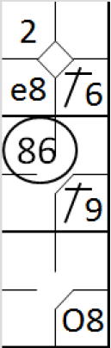 |  | /* le premier batteur frappe un hit sur l'arrêt court */  action { batter -> 1B6 }  /* Le batteur suivant frappe un simple dans le champ droit, le coureur avance de deux bases */  action { batter -> 1B9 , runner1 -> ++ }  /* Le frappeur suivant frappe une fly dans le champ centre qui loupe la balle. Le défenseur récupère la balle et la renvoie à l'arrêt pour retirer e coureur arrivant en 2. Le coureur en 3 marque le point en profitant de l'erreur du défenseur du champ centre*/  action { batter -> O8 , runner1 -> 86 , runner3 -> e8 } |  | 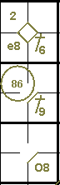

Example 56: With no men out and bases full, the third baseman recovers the ground ball hit by the fourth batter and, after touching his base, assists the second baseman inclosing the double play.
The batter-runner’s advance to first base is noted with the“occupied ball” symbol, along with “GDP” for grounded into double play.
The first runner’s advance is entirely legal although the run cannot be counted as having been batted in.
WBSC |  | Traduction dans l’outil de scorage |  | Outil
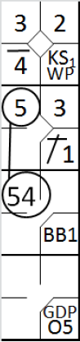 |  | /* le premier batteur arrive sur base sur strike relâché (wild pitch) */  action { batter -> KSWP }  /* Le batteur suivant frappe un simple sur le lanceur, le coureur avance */  action { batter -> 1B1 , runner1 -> + }  /* Le batteur suivant gagne la première base sur un 'base on ball', les coureurs avance */  action { batter -> BB , runner1 -> + , runner2 -> + }  /* le batteur suivant frappe une balle au sol vers le défenseur de la troisième base qui touche sa base. Il relai en suite la balle au défenseur de la deuxième base qui retire le coureur arrivant de la 1. Le coureur en 3 en profite pour marquer */  action { batter -> GDPO5 , runner1 -> 54 , runner2 -> 5 , runner3 -> + } |  | 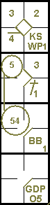

Example 57: The batter-runner, after having reached first baseon fielder’s choice, takes advantage of the ongoing rundown play to continue to second.
This additional advance is noted with an arrow.
WBSC |  | Traduction dans l’outil de scorage |  | Outil
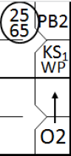 |  | /* le premier batteur arrive sur base sur strike relâché (wild pitch) */  action { batter -> KSWP }  /* Le coureur en profite d'un 'pass ball' pour avancer en 2 */  action { runner1 -> PB }  /* Le frappeur frappe une balle sur le receveur, qui relaie en troisième base pour retirer le coureur, une souricière élimine le coureur */  action { batter -> O2+ , runner2 -> 2565 } |  | 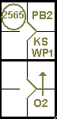
In the examples given hitherto, the symbol for “occupied ball” has onlybeen used to account for a batter-runner’s advance to first base. We shallnow look at how it may be used to account for advances by base runners.
Example 58: The first batter reaches base thanks to a bungled catch by an outfielder, and is forced to second when the next batter hits a single.
On a batted ball from the third batter, the shortstop assists the third baseman in putting out the first runner.
In this case also, the way the action developed gave the scorer the absolute certainty that the fielder could have put out the runner who was forced to second, rather than the first runner. For this reason, the runner’s advance to second base is recorded as a fielder’s choice, rather than with the batting order number of the batter.

WBSC |  | Traduction dans l’outil de scorage |  | Outil
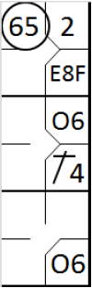 |  | /* Le premier batteur frappe une balle en champ centre, le défenseur fait une erreur el la rattrapant */  action { batter -> E8F }  /* Le batteur suivant frappe un hit sur la deuxième base, le coureur avance */  action { batter -> 1B4, runner1 -> + }  /* Le batteur suivant frappe une balle sur l'arrêt court, qui relai au troisième base qui retire le coureur venant de la 2. Le coureur en 1 et le batteur coureur en profite pour avancer */  action { batter -> O6, runner1 -> O6, runner2 -> 65 } |  | 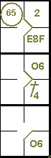
There is another kind of occupied ball, as in “KO2”.
Example 59: With runners on second and third, the catcher drops the third strike but recovers it in time to assist the pitcher to put out the runner who has just left third base.
The batter-runner arrives safely on first base, as indicated by“KS1 O2” (assuming that this is the first strikeout for the current pitcher).
The advance by the runner on second is noted with ‘O2’ as the provision of rule 9.13(b) Comment.
WBSC |  | Traduction dans l’outil de scorage |  | Outil
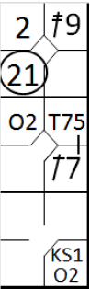 |  | /* Le premier frappeur frappe un double dans le champ droit */  action { batter -> 2B9 }  /* Le batteur suivant frappe un simple dans le champ gauche et profite d'un relai pour gagner le deuxième base, le coureur en 2 avance */  action { batter -> 1B7 T75, runner2 -> + }  /* Le batteur suivant, sur un troisième strike relâché, gagne la une car le receveur décide d'éliminer le coureur arrivant de la troisième base */  action { batter -> KSO2 , runner2 -> O2, runner3 -> 21 } |  | 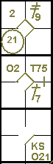

Example 60: The batter hits a ground ball to the third baseman, who tags the runner on third as he tries to retouch base.
In the encounter, however, the ball is dropped and the umpire calls “Ball on the ground”. The runner on third returns safely to the base and the third baseman is charged with an error.The error is decisive and must be noted in small characters in the third base square.
WBSC |  | Traduction dans l’outil de scorage |  | Outil
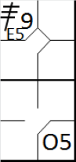 |  | /* Le premier batteur frappe un triple dans le champ droit */  action { batter -> 3B9 }  /* le batteur suivant frappe une balle sur la troisième base, le défenseur aurait du retirer le coureur qui ne bouge pas */  action { batter -> O5 , noAdvance on runner3 -> E5 } |  | 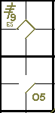

This type of error will always be encountered on third or second base, and should not be confused with an error that prolongs a time at bat which, although it is recorded in the same manner, is written in the first base square.
ATTENTION: To account for a runner’s advance on a fielder’s choice rather than on a hit, the scorer must be absolutely convinced that an alternative play on that player would have led to his being put out.

